***Task # 03***

***Tasks***:

1. Place a hyperlink in your Institute name and link that text to your Institute official page.

**[ALIGARH INSTITUTE OF TECHNOLOGY](https://aligarh.edu.pk/)**

1. Create an unordered list of your courses name.
   * + Islamiat/Pakistan studies
     + English
     + Applied chemistry
     + Applied Physics
     + Occupational health ,safety & environment
     + Computer application software
     + Introduction to computer programming
     + General engineering workshop
     + Electronics

1. Write an application to your principal for full fee concession on word.

GR # **002**

**MUZAMMIL**

**The Principal,**  
Aligarh Institute Of Technology,  
Karachi,

**Subject: Request for Full Fee Concession**

Dear Sir/Madam,

I hope this letter finds you in good health and spirits. I am a student of 1st year at your esteemed college. I am writing to respectfully request a full fee concession for the current academic year due to financial difficulties faced by my family.

Unfortunately, due to unforeseen circumstances, my family is currently undergoing significant financial hardship.It has become increasingly difficult for us to meet the financial obligations required to pay the full fees for my education.

I would be extremely grateful if you could look into my situation and grant this concession. I assure you of my continued dedication to my academic progress and overall conduct in school.

Thank you for your time and consideration. I look forward to your kind support and a favorable response.

Yours sincerely,

Muzammil

Top of Form

Bottom of Form

1. Change the page orientation to Portrait.

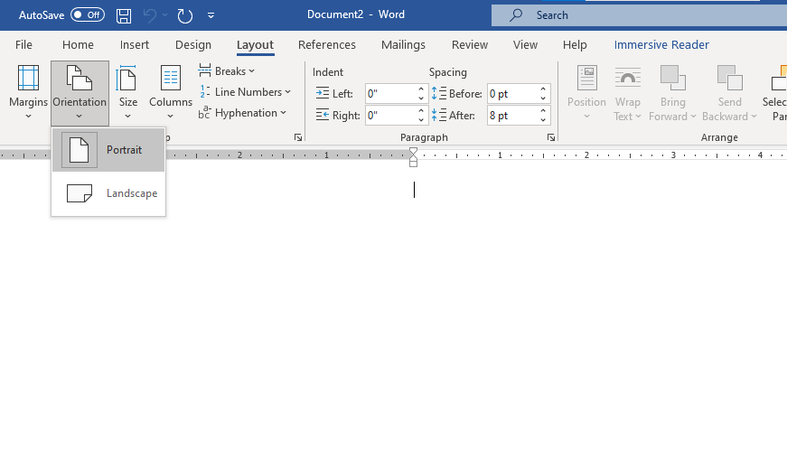

1. 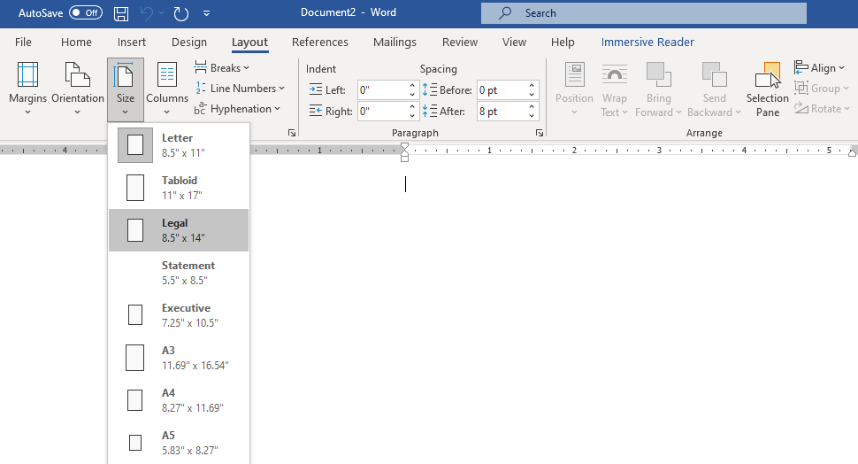Change the page size to Legal. If Legal size is not available, you can choose another size such as A5.
2. Change the margins to the Narrow setting.

